Understand Asymptotic Notation
Big O Notation Big O notation is a mathematical concept used in computer science to describe the performance or complexity of an algorithm. Specifically, it describes the worst-case scenario, answering the question: "As the size of the input data (n) grows toward infinity, how does the algorithm's runtime or space requirement grow?" It helps us evaluate whether an algorithm will scale effectively as our e-commerce platform gains more products.
Search Operation Scenarios When analyzing search algorithms, we look at three distinct scenarios:
- Best-Case: The target element is found immediately. For both linear and binary search, the best-case time complexity is O(1) (constant time). This happens if the target is the first element checked (the first item in linear search, or the exact middle item in binary search).
- Average-Case: The expected time it takes to find a target randomly located in the array.
- Worst-Case: The target is located at the most disadvantageous position (e.g., the very end of the array) or isn't in the array at all. This dictates the Big O notation.

Output:

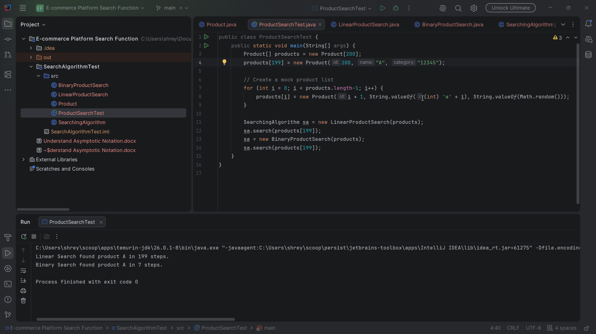

Analysis
Time Complexity Comparison
Algorithm | Best-Case | Average-Case | Worst-Case (Big O) | Space Complexity
Linear Search | O(1) | O(n/2)≈O(n) | O(n) | O(1)
Binary Search | O(1) | O(logn) | O(logn) | O(1)

- Linear Search (O(n)): If the e-commerce site has 1 million products, a worst-case linear search requires 1,000,000 checks. The time taken grows proportionally with the catalog size.
- Binary Search (O(logn)): Because the search space is cut in half at every step, searching 1 million products takes at most about 20 checks (log2​(1,000,000)≈19.9).
Platform Suitability
For an e-commerce platform, Binary Search (or variations of it) is overwhelmingly more suitable for retrieving specific products by ID. The performance difference between O(n) and O(logn) becomes massive as their inventory grows; linear search would cause unacceptable lag for users.

